CS 470 Module Four Assignment One Guide

Part One: Creating and Testing a Lambda

- Navigate to AWS Lambda by typing “Lambda” in the console search bar or selecting Lambda under Compute.

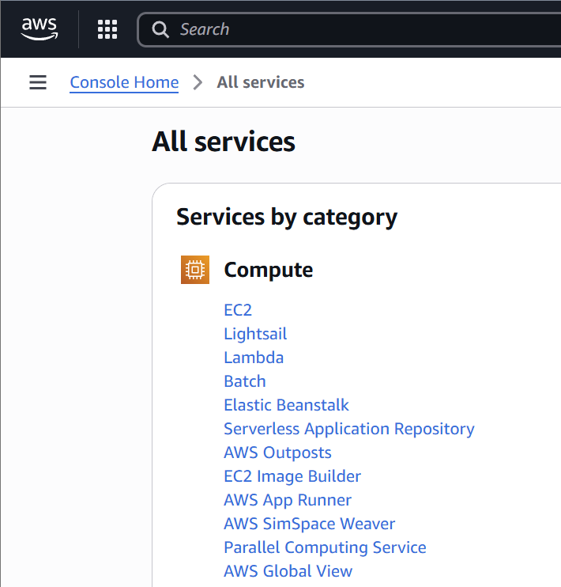

- Click the orange Create function button in the upper-right corner.

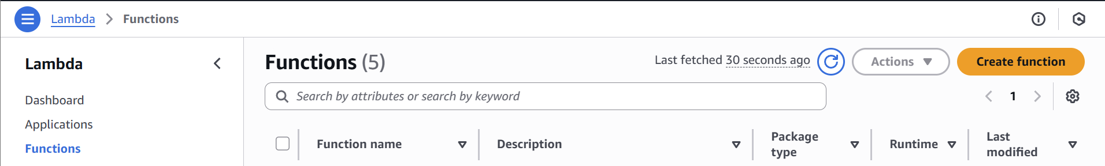

- Make certain Author From Scratch is selected.
- Enter the function name “EchoFunction”.
- Set the runtime to Node.js 20.x.
- Set the permissions option set to Use an existing role.
  - Choose LabRole from the Existing role menu.
- Click the orange Create Function button in the lower-right corner.

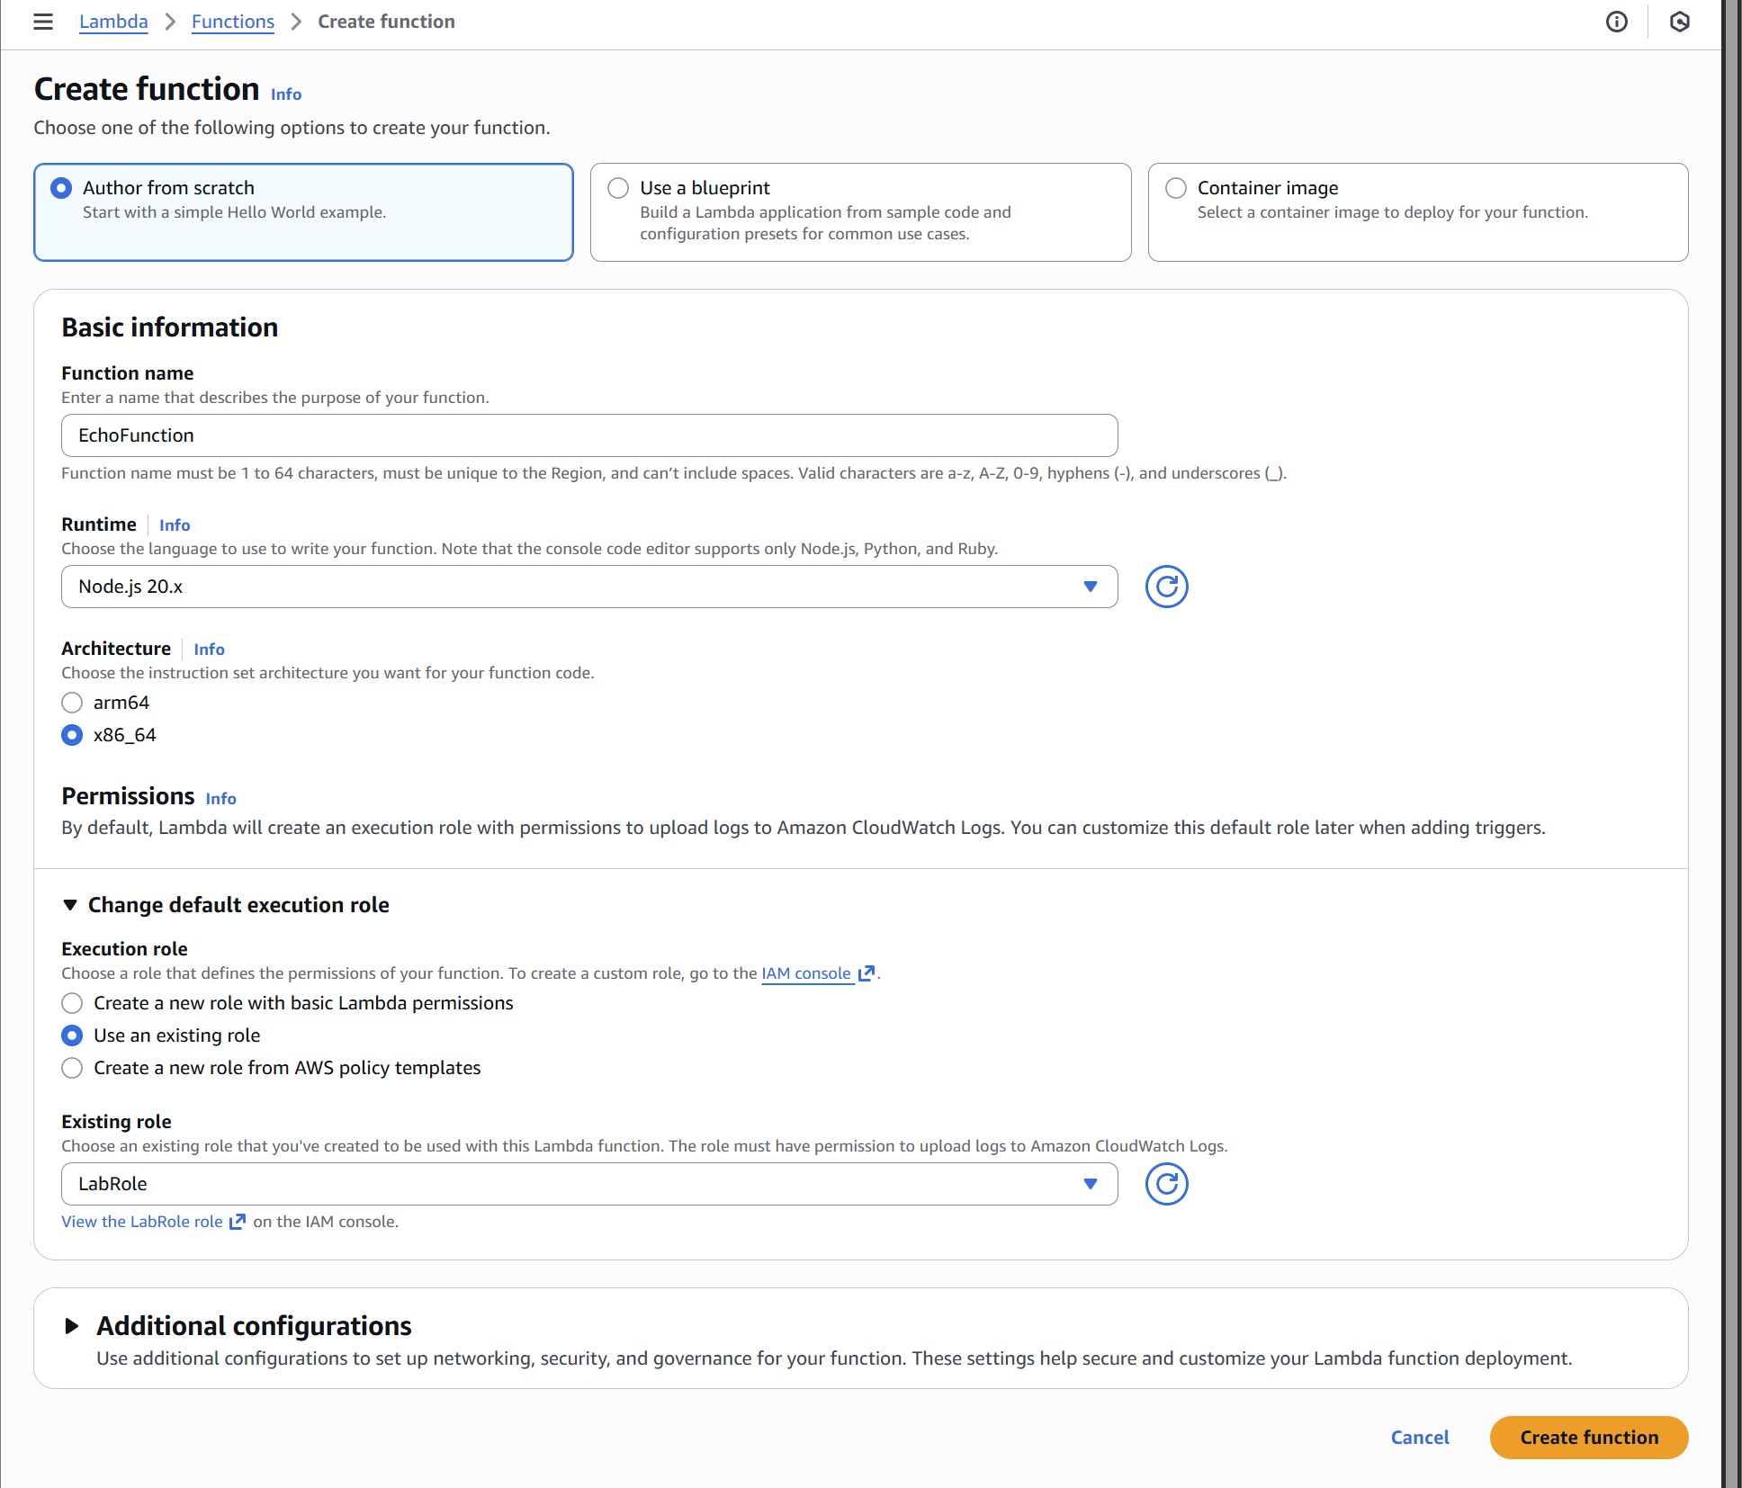

- Click Dismiss on the Getting Start modal.
- Congratulations! You have created your first serverless compute function: a bouncing baby Lambda! You should now see a screen like the screenshot below.

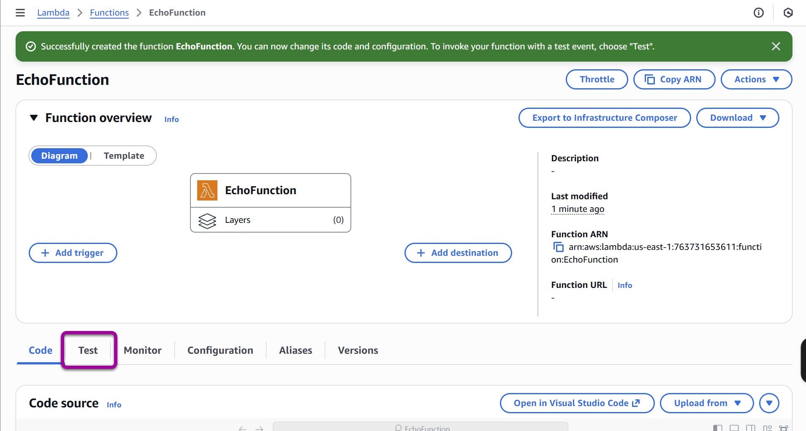

- Click the Test tab on the left side of the screen where the pink rectangle is highlighting in the image above.
- In the Test event window, enter “SimpleTestWithJsonData” in the Event Name box.
- Leave everything else the same and click the Save button in the upper-right part of the screen.

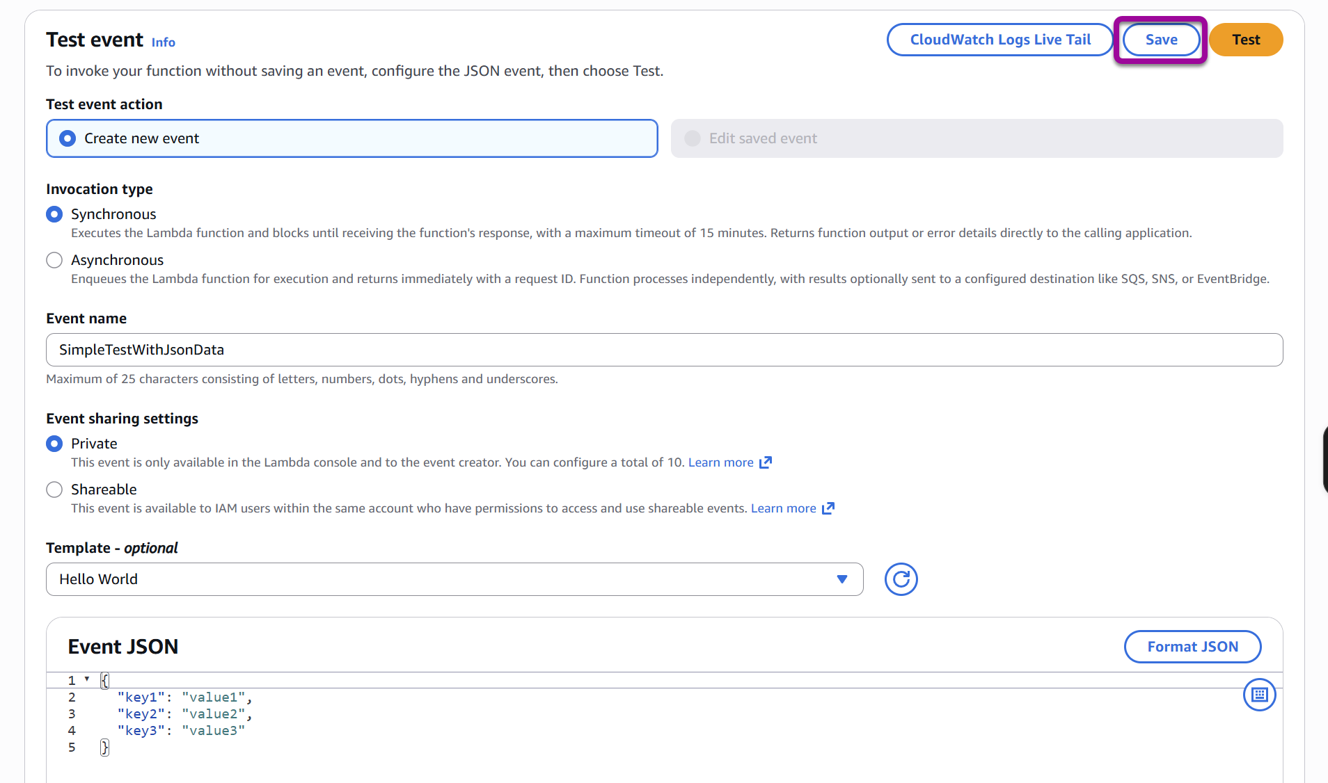

- You will still be looking at the Test tab in the Lambda console.
- Now, click on the Code tab. You will see the inline Lambda code editor in the Code source box. Double-click the index.mjs symbol on the left side of the screen. The code for the function will appear.
- You will review the code in a moment. For now, click the Test button in the editor.

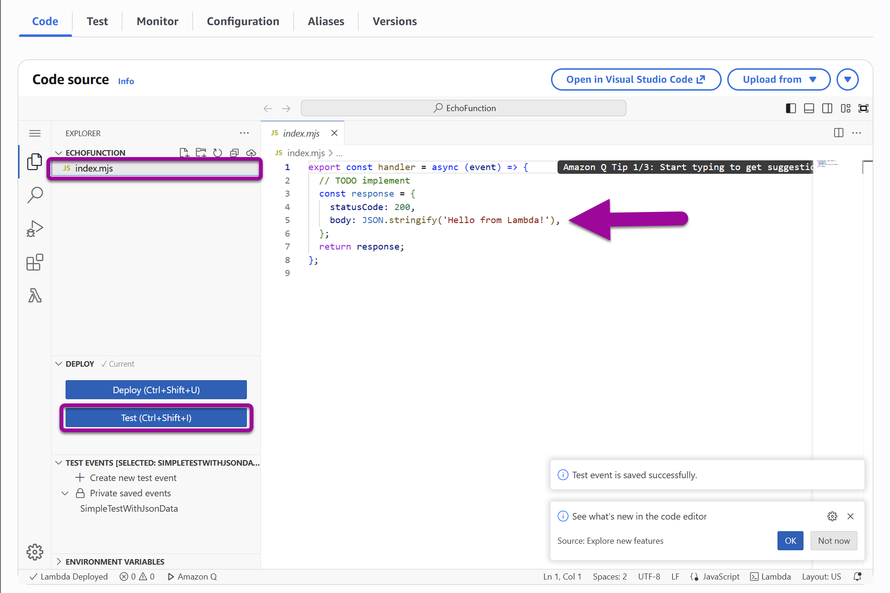

- Congratulations! You have run your first Lambda. Your screen should look like this:

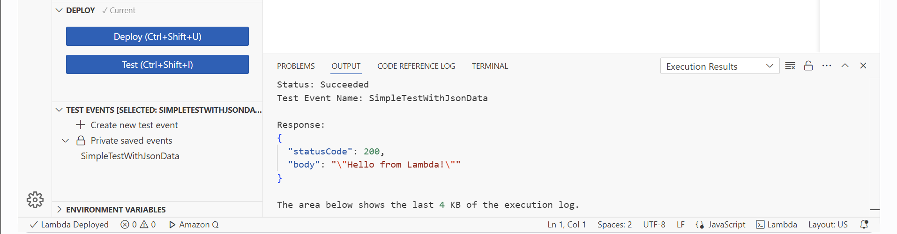

Part Two: Creating an Echo Function

- You will modify the code provided by AWS to perform a simple echo function.
- Add the following code to index.mjs after the response object is created and before the return:

// log the event to the logger
console.log("Event: \n" + JSON.stringify(event));
// log the response to the logger
console.log("Response: \n" + JSON.stringify(response));

- Your code should look like this:

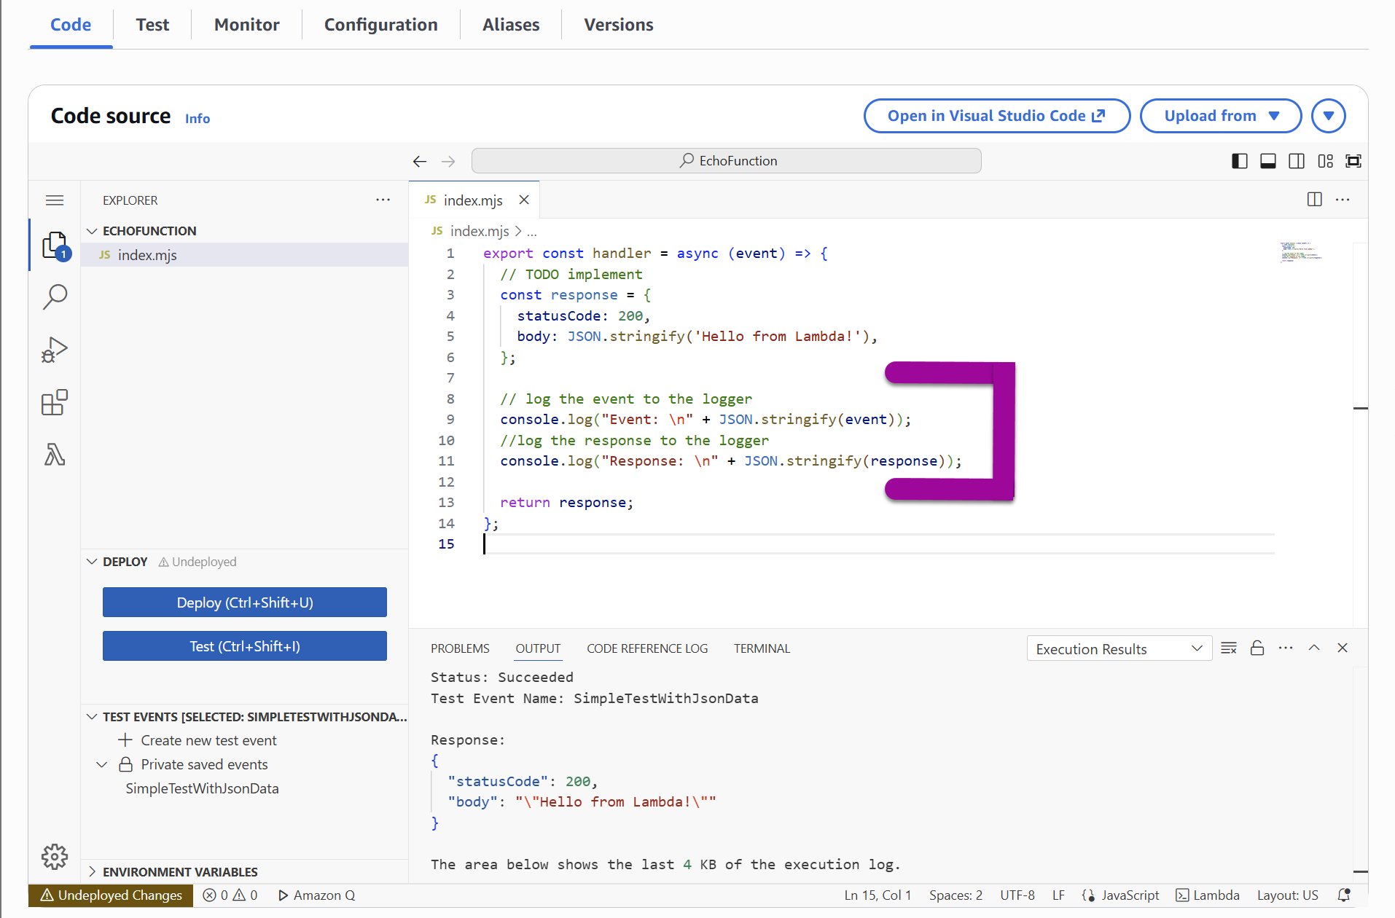

- Click Deploy.
- Click Test again.
- Your execution results will now look like this:

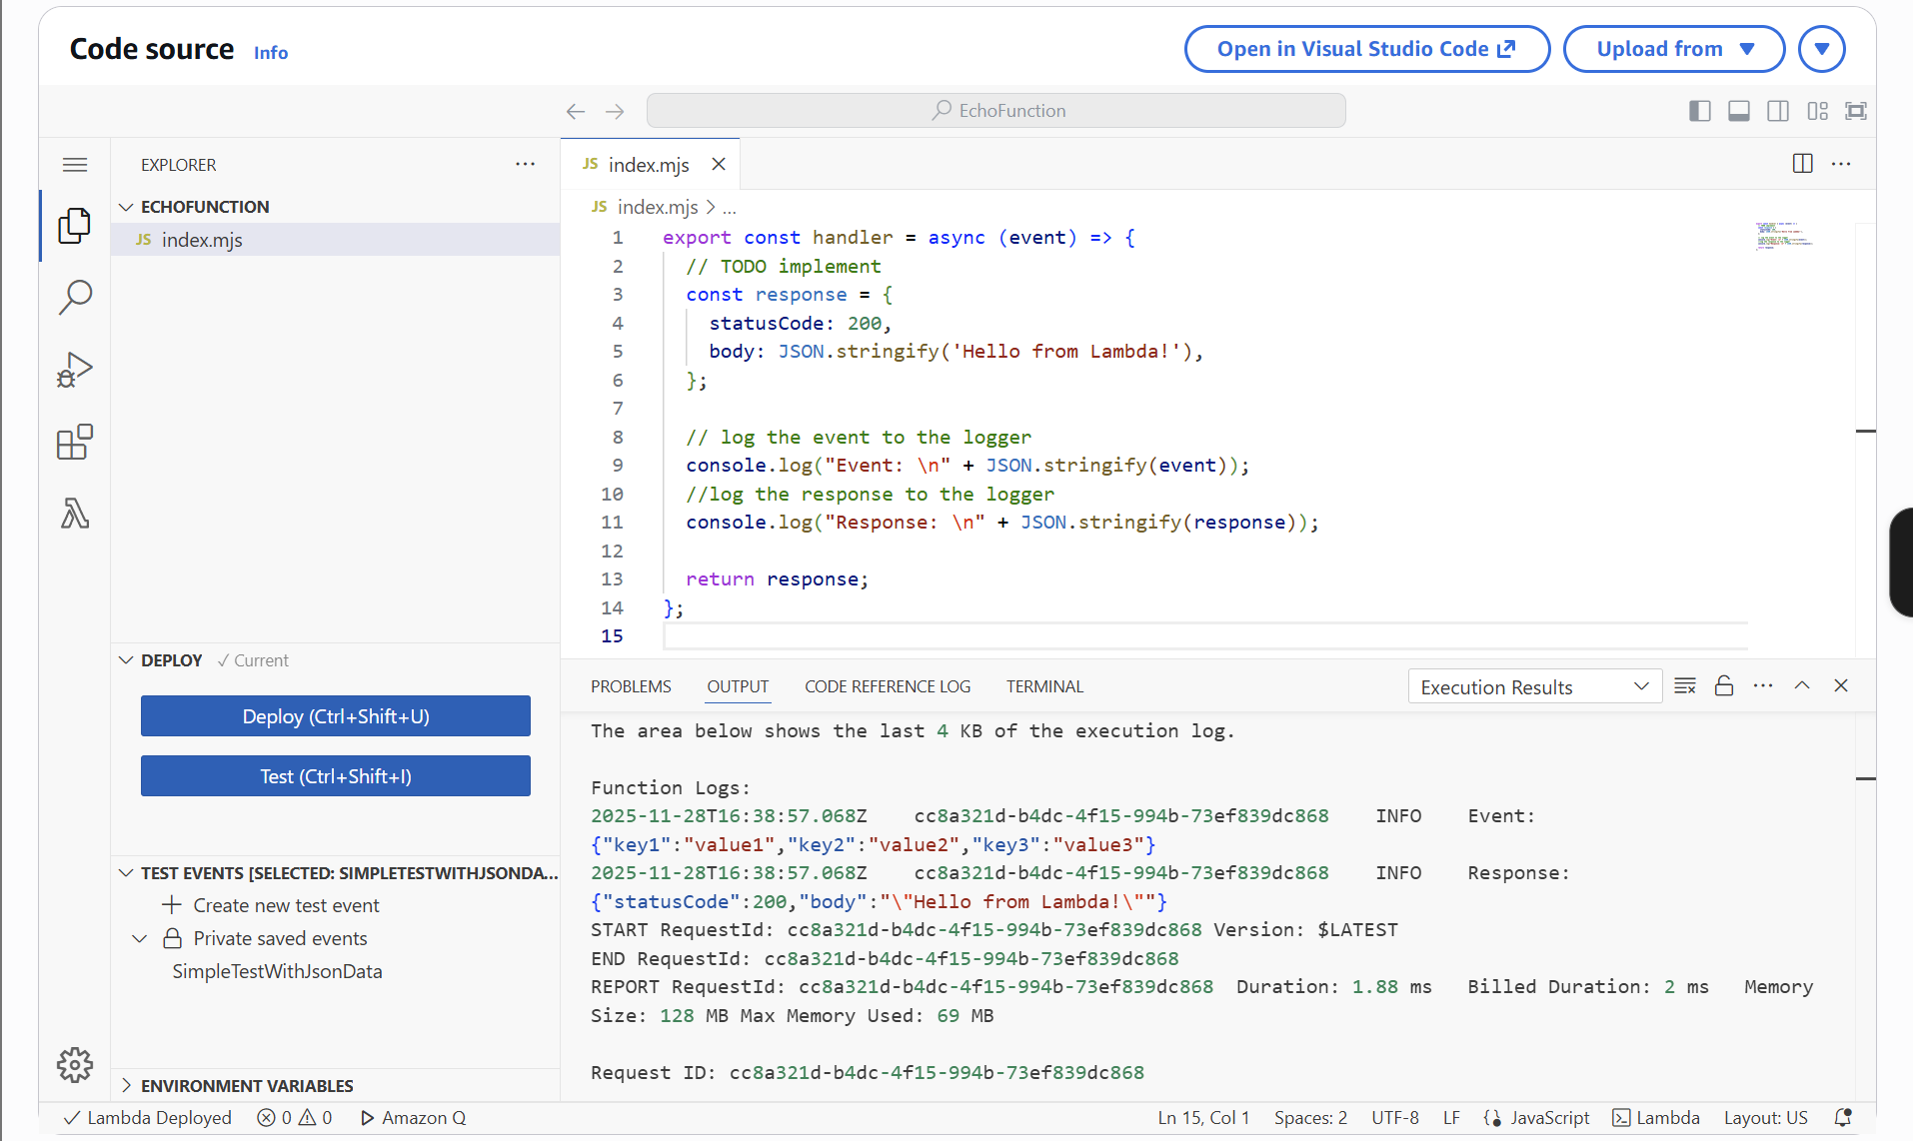

- The values you passed in through the SimpleTestWithJsonData test event are now logged as the event object. Your response is the response object being created.
- Modify the code so the response echoes what was passed in. This modification will change the following code from this:

body: JSON.stringify('Hello from Lambda!'),

to this:

// create some text to send back to the client
body: JSON.stringify(event),

- Make certain to click Deploy when done.
- Click Test again. Your execution results should look like this:

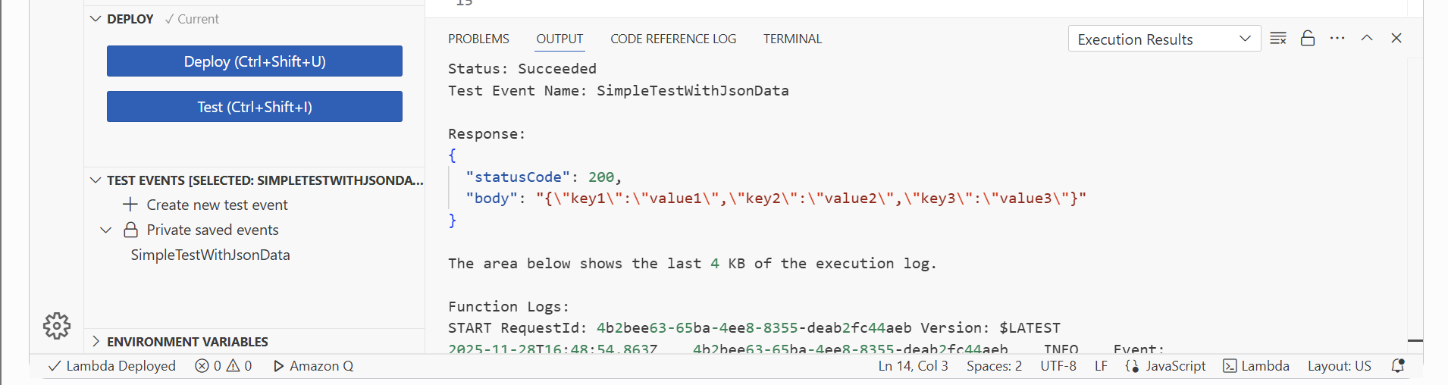

Part Three: Enhancing the Echo Function

- You can now echo your results, at least for the JSON data that was passed in. Now, you’ll do something different.
- Select Create new test event.

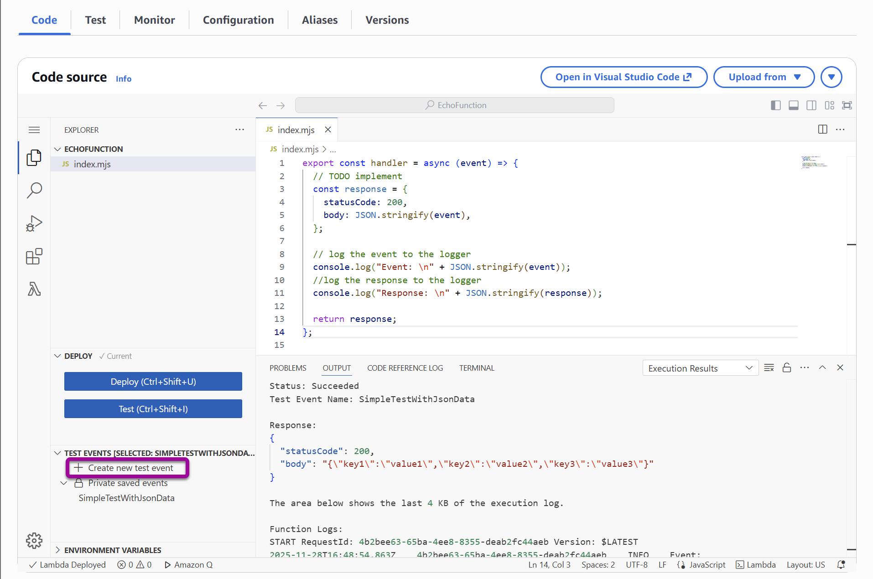

- Name it “EchoWithQuery” in the Event Name box, replace the default JSON with the following:

{
"queryStringParameters": {
"name": "David"
}
}

- Click Save, then close the Create new test event tab.

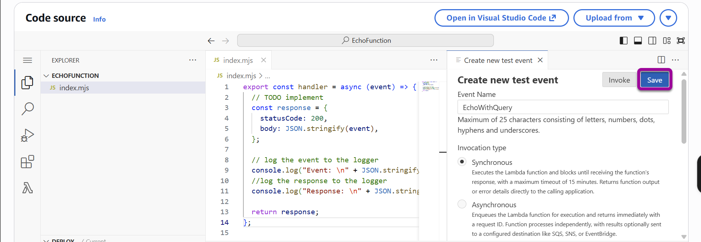

- Replace the code below the “// TODO implement” starting at line 3 and overwriting through the existing line 6, using the code below. Leave the log statements and the return response lines unchanged.

var name = 'unknown';
if (event.queryStringParameters && event.queryStringParameters.name) {
console.log("Received name: " + event.queryStringParameters.name);
name = event.queryStringParameters.name;
}

const response = {
statusCode: 200,
body: "Hello " + name
};

- Click Deploy.
- Run your EchoWithQuery test. You should see the following output results:

Note: if your output in the body does not render the name “David” check that your changes Deployed before testing.

